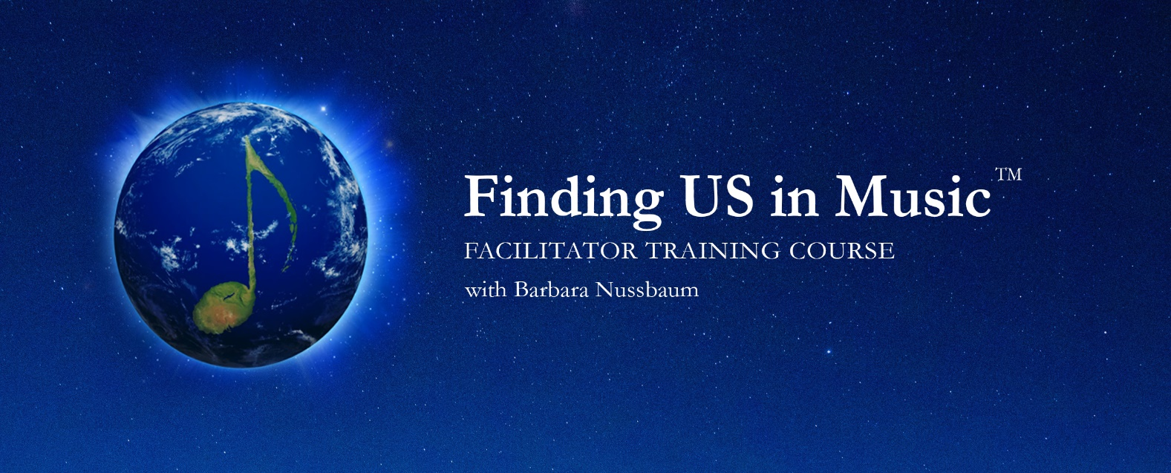

**APPLICATION FORM**

Your name: …………………………………………………………………………………….

Preferred email address: ……………………………………………………………………….

Your website:……………………………………………………………………………

Cell phone: ……………………………………………………………………………………

_____________________________________________________________________________________________________

This application form is designed for a few purposes:

* to stimulate your own thinking and clarify your intentions about your desire to enroll for the course.
* to discern your learning objectives and what this course can offer you.
* administrative information

To review your application, its best to answer all the questions. ALL IN 200 words or less per question.

Your answers are all simply gifts that you bring to your learning journey and our ability to support your objectives.

1. What has attracted you to this course?
2. Why does Finding Us in Music speak to you?
3. Tell us about your facilitation experience? How many years have you been facilitating and in what contexts?
4. And how might a Finding Us in Music approach support you to carry out your own personal mission? (200 words or less)

5. What was one special moment when you felt true self- mastery when you were a facilitator?

6. Tell us about your connection and experience with music?

7. What outcomes from the course would make it a real success for you?

8 Contact details:

Preferred social media address: …………………………………………………………

City and country of residence: …………………………………………………………

Organizational affiliation(s): ……………………………………………………………

Please complete and return this application form, to [barbara.nussbaum@gmail.com](mailto:barbara.nussbaum@gmail.com) on or before June 20 2021